**WELCOME TO FEA**

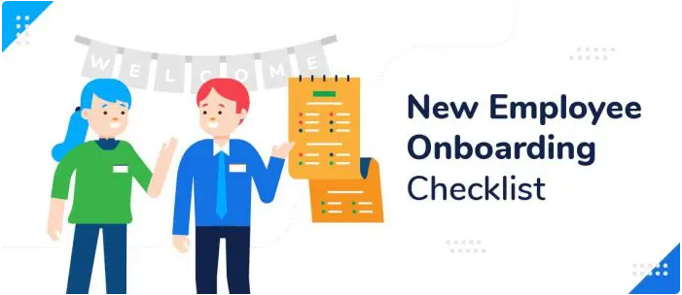

**About FEA**

FEA offers two different free programs, in north India’s Hindi belt, for urban youth and for rural youth to build productive and ethical mind-sets and core employability skills**.**

**The rural program** for youth in the 18+ age group is of 1 year duration. Students attend classes at FEA branches in their villages for two and half hours per day, six days a week.

**Our free classes build** ethical, productive mind-sets and core employability skills, including English language and digital literacy. Additionally, we provide career guidance and mentorship.

Cumulatively, about a quarter of a million students have enrolled in FEA since its inception in 2010.

**What is Team FEA?**

**Team FEA exists to help alleviate poverty in India. We are doing this by enabling FEA students to learn core employability skills and to develop ethical and productive mindsets, so they can take care of their families and become contributors to the nation and to humanity.**

**Team FEA is a group of lifelong learners who continuously strive to be kind, compassionate, generous, and forgiving. Our minds are free of fear, anger, greed, unkind thoughts, or negative thinking.**

**Team FEA is thoughtful, considerate, and polite. We discuss ideas rather than people, believe in resolving conflicts rather than holding grudges, nurture goodwill and not resentment, do not discriminate based on caste, religion, economic status, or abilities and are unwilling to retaliate. We believe in loving the whole world like a mother loves her only child. We do not compare ourselves with others and we do not judge others.**

**Team FEA derives a quiet satisfaction from leading a life of selfless service. We believe it is in giving that we receive.**

***­­***



**Table of Content**

|  |  |  |
| --- | --- | --- |
| S.no |  | Page# |
| 1 | Job Expectations: FEA India | Already available |
| 2 | How to avoid embarrassment of dismissal | Already available |
| 3 | Child protection policy | Already available |
| 4 | Leave Policy & dashboard | 5 |
| 5 | Expense Management & dashboard | 7 |
| 6 | Medical Policy | 10 |
| 7 | Emails guidelines | Already available |
| 8 | Admin | 10 |
| 9 | Branch team meeting | 10 |
| 10 | Zonal meeting | 10 |
| 11 | IT Management | 11 |
| 12 | IT Resource Entry Process | 12 |
| 13 | Visitor’s Log | 16 |
| 14 | Enrolment Process | 16 |

# Job Expectations: FEA India

Please visit FEA website- http://43.252.88.75:8080/Rural%20Branch%20Staff%20Job%20Expectation_%2018.5.24.pdf

# LEAVE POLICY

Please visit FEA website- http://feagraduate.org/leave%20policy%202023.pdf

**How to apply for a Leave-**

Step1- Log in to http://43.252.88.75:8087/login.aspx

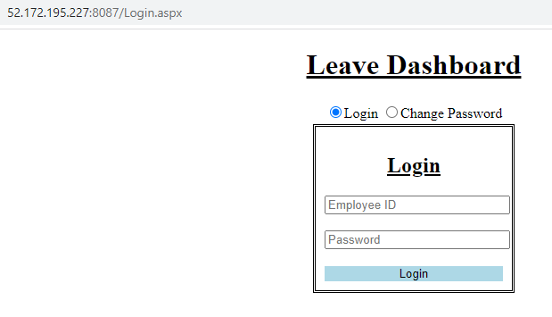

Note-

Employee ID and password will be shared by the manager at branch.

Precaution- as soon shared by manager, please change the password and not share with others

Step2- Click on apply leave

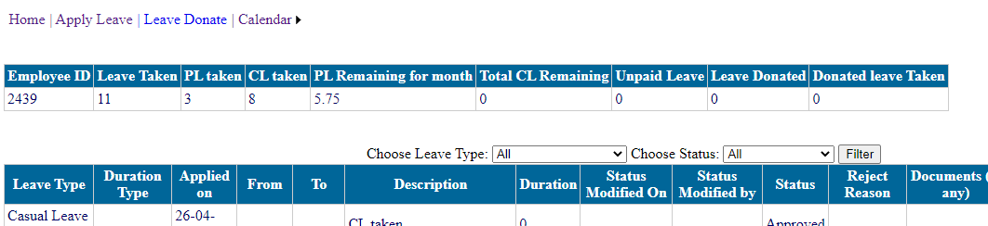

Step3- Select leave type

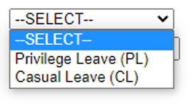

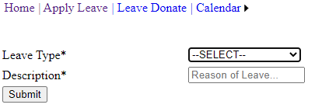

Step4- If PL is selected, update the mandatory details and submit

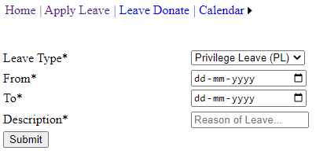

**Your leave application is successfully submitted. Please check, you must have received an email of the same, now wait for manager’s approval which is expected within 24 to 48 hours.**

**Note- Please call your manager if you don’t have 48 hours to wait for approval.**

# EXPENSE MANAGEMENT

**“While uploading bills, please ensure the following:**

Please visit FEA website- <http://103.27.234.18:8080/Guidelines%20for%20submission%20of%20expense%20dashboard%20bills%20V.25.5.24.pdf>

**Note-** The rural branch staff is paid for their travelling expenses if the branch is over 5KM from their home. The staff will upload their expenses using the attached file based on number of working days in the category of “conveyance” instead of “vehicle running and main.” The total amount spent in a day will be calculated keeping the average of 40KM/liter for any vehicle, though the distance will vary for each staff. No separate calculations to be made for the ones using any public transport, as we don’t encourage rural staff use public transport for travelling when hired.

All these expenses to be uploaded on 1st of the month and expected to process by TM by every 2nd of the month.

**How to claim an expense-**

Step1- Log in to <http://43.252.88.75:8086/login.aspx>

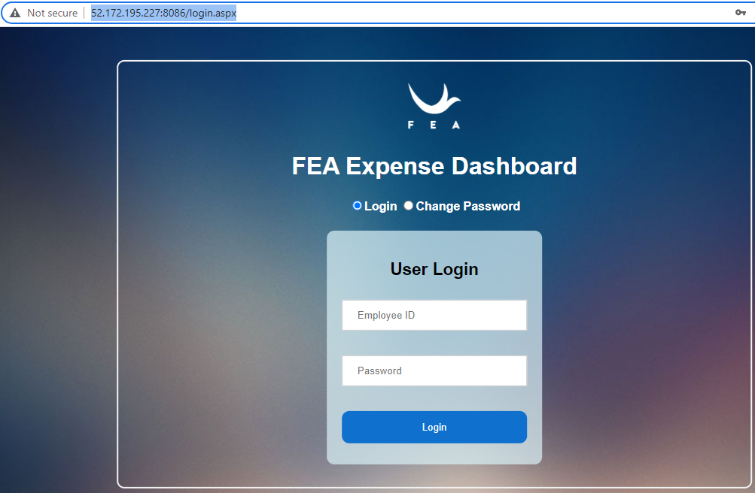

Step2- Click on “Book Expense”

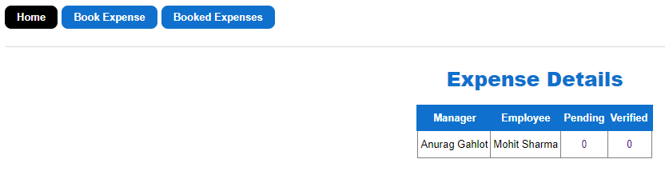

Step3- Fill out the mandatory details as per the guidelines mentioned in red highlights and submit your expense

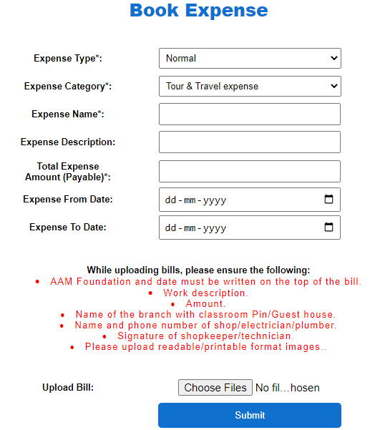

**Your expense is successfully submitted. Please wait for your manager’s approval.**

To check the booked expenses status: Go to booked expenses (just beside of book expense section)

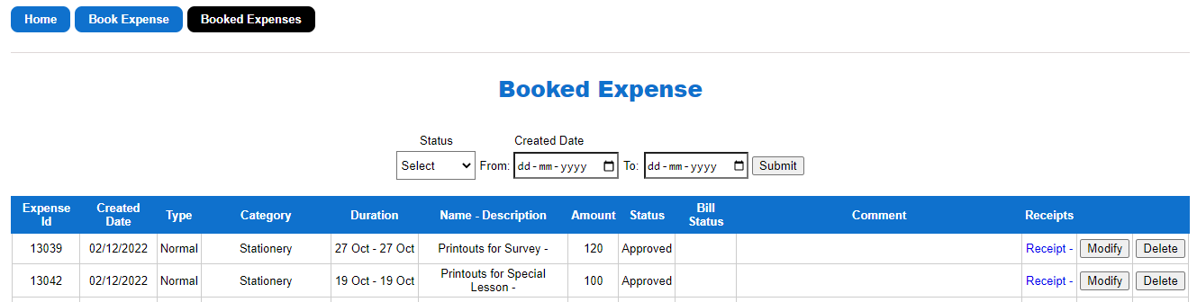

# MEDICAL REIMBURSMENT POLICY

Please visit FEA website-

<http://feagraduate.org/Medical%20Policy_2022.pdf>

<http://feagraduate.org/AAMF%20Medical%20policy_Modification%201.5.22.pdf>

EMAIL GUIDELINES

<https://qko858.n3cdn1.secureserver.net/wp-content/uploads/2023/08/FEA-e-mail-guidelines-v10.08.23.pdf>

ADMIN

Admin time is used to complete FEA work ONLY. The facilitator must read all the emails, and reply if needed, call absent students and upload call logs, plan home visits if required (as per the discussion with TM), or any other day-to-day activity. Admin time must be utilized to the fullest.

# BRANCH TEAM MEETING

Branch Team Meeting is used to uplift performance of staff and branch among 4-5 staff on ZOOM platform. The BTM is led by one of the selected branch staff form the group.

* Staff to attend the meeting on time without fail.
* Branch team meeting to be conducted every Tuesday
* The staff hosting the meeting to share MOM with the participants, TM, AM, and SAM within 24 hours.

# ZONAL MEETING

Zonal meeting is led by the territory manager to share the updates/changes in the policies/processes/curriculum, etc.

* Participants to attend the meeting on time without fail using ZOOM platform
* Zonal meeting is conducted every Friday (It may take place more days based on requirement)
* The TM to share MOM with all the participants including the ones who missed to attend the meeting.

IT MANAGEMENT

IT assets are the essential and most expensive tools of students’ learning. These must be kept safe and secured at all the time

|  |  |
| --- | --- |
| **IT Management** | |
| Do’s and Don’ts | * All the laptop tables must be clean and kept tidy. * Chargers, earphones, phones, notepads, or any other objects must not be kept on the laptop. * Laptop wires must kept organized using duct tape and zip wires clamps, as done by manager at first. * Water bottles must not be kept on the Laptop table. |
| IT resource log/register/cop by branch staff | * The laptop register must be maintained in the prescribed format requiring all details asked in it. * IT log database must verified by the facilitator at the beginning and end of the session. * IT resource page must be updated in case any IT asset not working properly. * Follow-up needs to be taken if no response is received from IT team or immediate manager. |

**Waitlist and Laptop Register**

* Waitlist pages to be used collect the data of walk ins in case of 100 % enrolments at the branch.
* First 3 pages of the “Waitlist and Laptop Register” will be dedicated to the Waitlist format only to collect the data.
* Walk-ins to be guided after discussion to update their details on the page, they will be contacted once there is any vacancy in the preferred session.

**Format of Walk-ins entry Page:**

|  |  |  |  |  |
| --- | --- | --- | --- | --- |
| Sr. no. | Name of the student | D.o.B | Contact no. | Preferred Session |
|  |  |  |  |  |
|  |  |  |  |  |
|  |  |  |  |  |
|  |  |  |  |  |

**Format of Laptop usage entry Page**:

|  |  |  |  |  |  |  |  |  |  |  |  |  |
| --- | --- | --- | --- | --- | --- | --- | --- | --- | --- | --- | --- | --- |
| Date | Session | Laptop Monitor | Check in time | No. of laptops | No. of earphone | Laptop monitor sign | Check out time | No. of laptops | No. of earphones | Comment | Laptop Monitor Sign | Facilitator Sign |
| 27-Jul 22 | 1 | XYZ | 8:55 am | 10 | 10 | XYZ | 11:22 am | 10 | 10 |  | XYZ | MNO |
| 27-Jul 22 | 2 | ABC | 11:23am | 10 | 10 | ABC | 1:52 pm | 10 | 10 |  | ABC | MNO |
| 27-Jul 22 | 3 | DEF | 2:10 pm | 10 | 10 | DEF | 4:36 pm | 10 | 10 |  | DEF | MNO |

**Note: Laptop cop to make the entry in the register at the time of reaching and leaving the branch. In case of absence of the cop, facilitator to make the entry.**

# IT Resource Entry Process

IT resource page it to be updated to update the details of non-working laptops, requirement of earphones, laptop chargers, or any other issues witnessed with laptops/earphones/chargers.

The theft/missing/damaged IT asset and internet related issues to be reported to the immediate manager immediately in all circumstances.

**Process to update the page:**

Log onto LMS and follow as per the black arrows

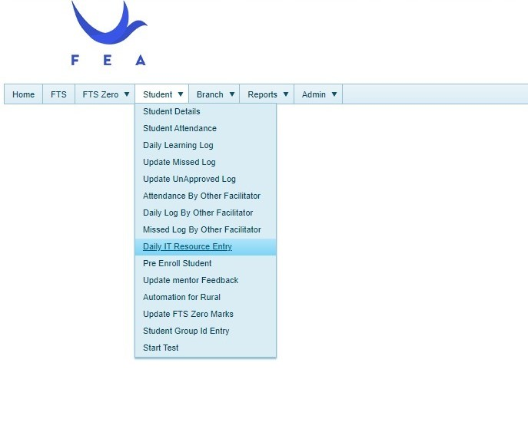

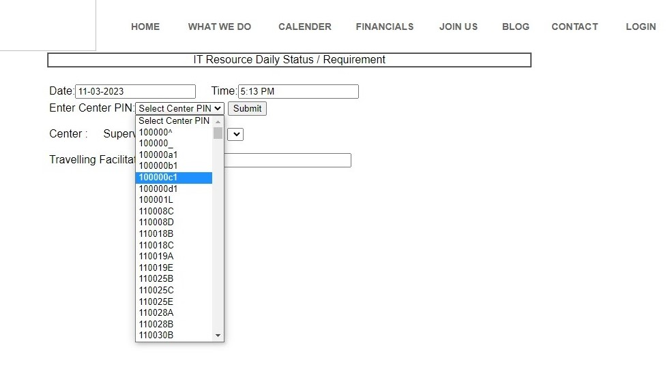

Center PIN is same as classroom PIN allotted to your branch. This is available on your LMS.

Always select the PIN of your branch and press “Submit”.

# 

# 

Always select “Yes”.

# 

# **Fill in the details about the non-working laptops, chargers and headphones as per the branch requirement and then click on Save.**

# **Once saved, the below page will become available to you. Kindly verify if everything is updated correctly as you had to update.**

To check the updated information on IT resource page, please follow the process mentioned below. In case of any discrepancies or concerns, kindly approach your immediate manager.

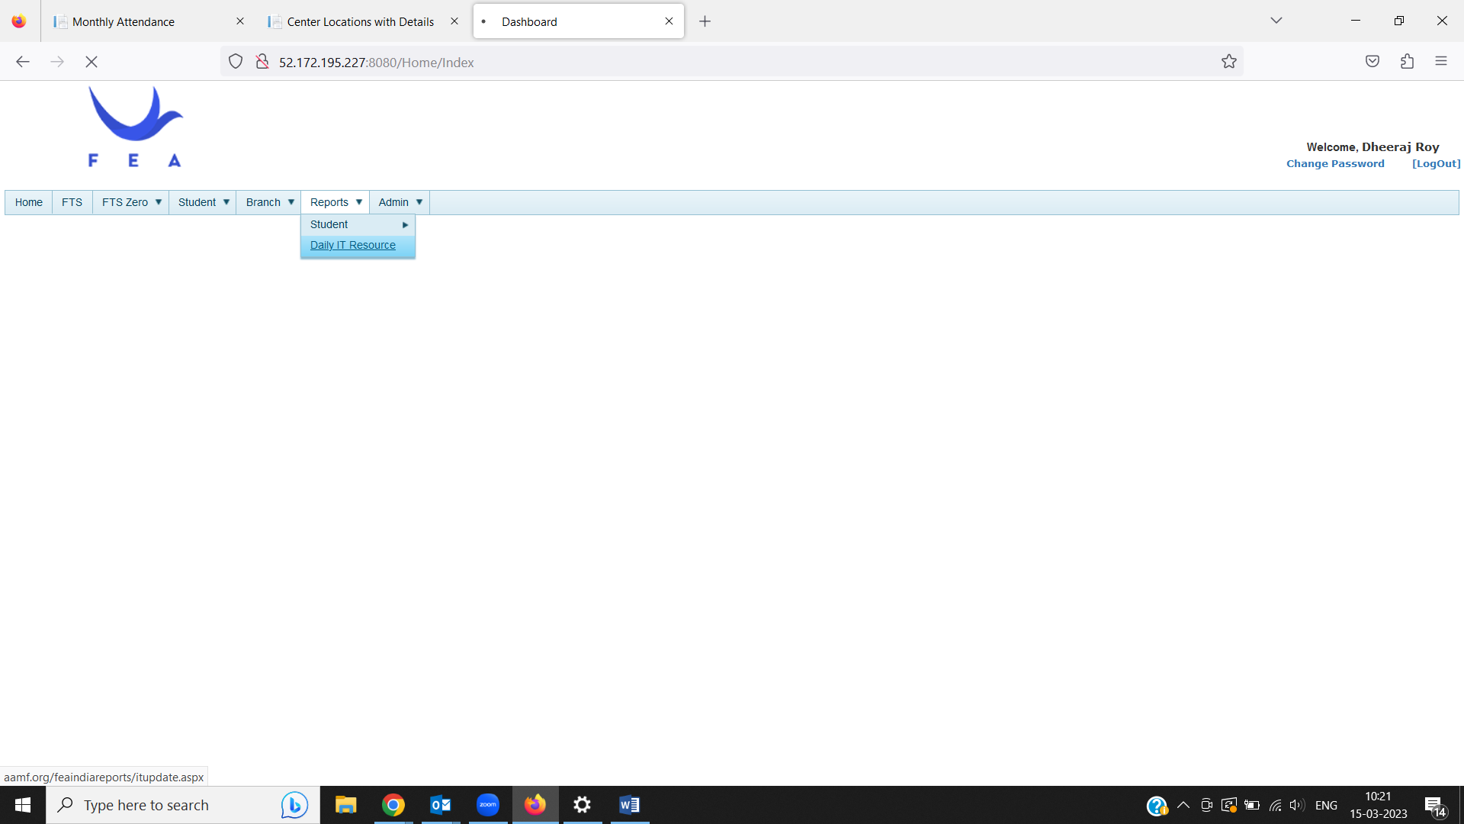

# LAPTOP COP IN CLASSROOM

The laptop cop counts the laptops and other IT assets at the beginning of the session and at the end of the session. S/he makes the entry as required in the laptop register available at the branch as and when the count is done (expected twice in a session). Facilitator does verify the entry at the end of each session and signs in the register.

**Note-** Entry made at the end of the session should meet the entry made at the beginning of the next session. Therefore, an interaction among cops from one session to other is mandatory.

# VISITOR’S LOG

Visitors' logs must be maintained by **clicking the picture** in the assigned laptop of every visitor (TM/AM/SAM/RH/CEO/IT custodian/SSE/any other FEA staff).

# LMS Practice videos:

<https://drive.google.com/drive/folders/1P9-FIJzT2R4_8--oXn66Dv0gZ32UF-0V>

# ENROLMENT PROCESS

|  |  |
| --- | --- |
| Day 1 at Branch - Calling Survey Data | |
| If 40+ students agreed to come | If less than 40 students agreed to come |
| Day 2- Follow up on survey data/Mobilisation | Day 2 & 3 Mobilisation |
| Day 3- Conduct lesson1 & Enrol students | Day 4/5 Conduct lesson1 & Enrol students |

**Facilitator must have 2 min of conversation with new students to know their qualifications and upcoming exams. This will help the facilitators to know the plan of students before the enrolment. Check the ID proof of student to verify the age of the student before enrolment.**

* How to enroll students of survey data or walk-ins by the facilitator?

Step1- Login using your FEA email ID on [www.feaindia.org](http://www.feaindia.org)

Step2- Once you login go to **students** then click on **students details**. (Please see the image below)

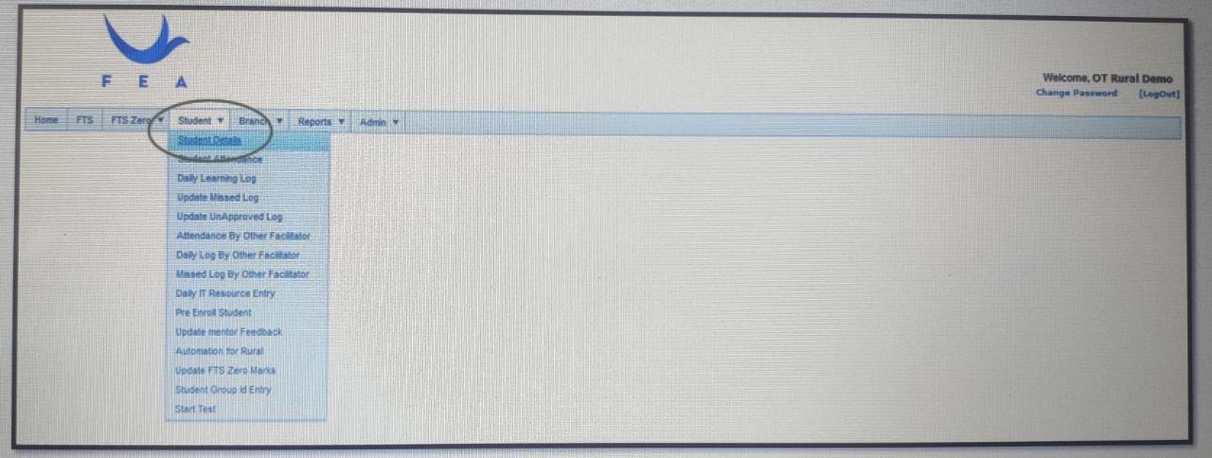

Step3- Click on Add student

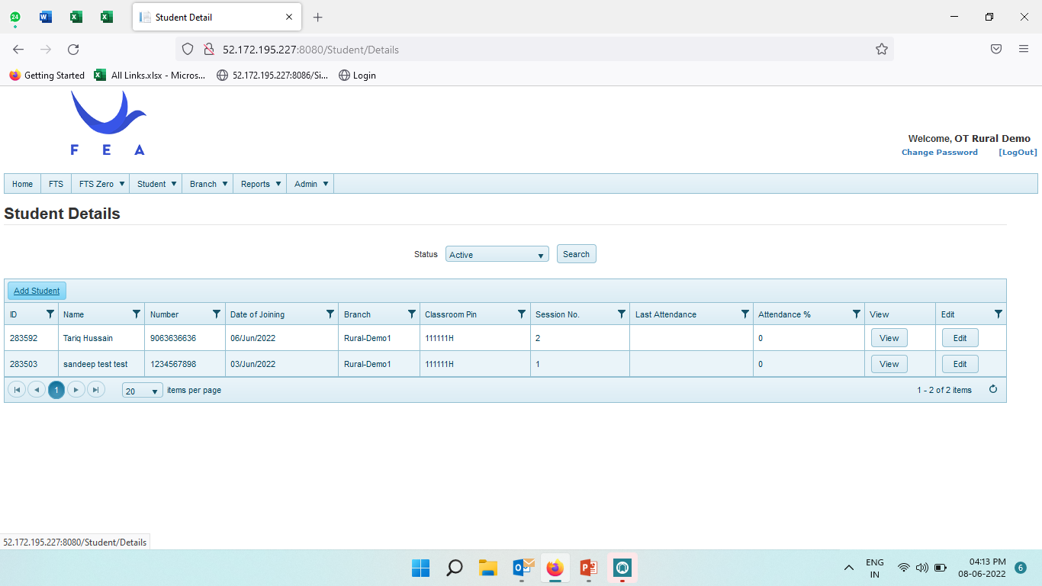

Step-4 Fill all the details mentioned on the screen

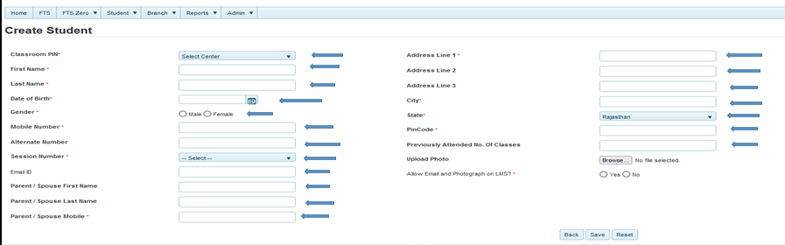

**Note-** It is must to check any authentic document for DOB. Such as Adhar card.

Step5- After filling all the details, please click on **save**.

**Sample entry for walk-ins:**

* First 3 pages of the “Waitlist and Laptop Register” will be dedicated to the Waitlist format only to collect the data.

|  |  |  |  |  |
| --- | --- | --- | --- | --- |
| **S.No** | **Name** | **DOB/Age** | **Contact No.** | **Session** |
| 1 | ABC | 1.Jan.1998 | 9876543210 | 2 |

**Important: The student must be enrolled the day s/he attends the 1st class**

**How to enroll a student when mobilization is done by the facilitator?**

Step1- Go to the mobilization link: <http://43.252.88.75:8080/ruralsignup.aspx>

Step2-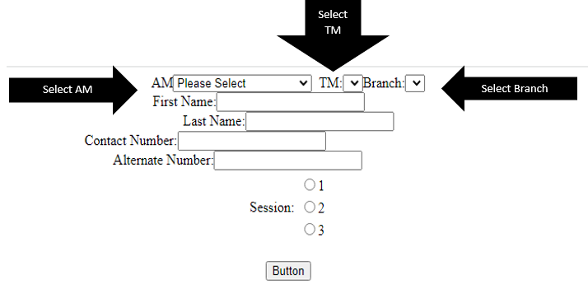

Step3-

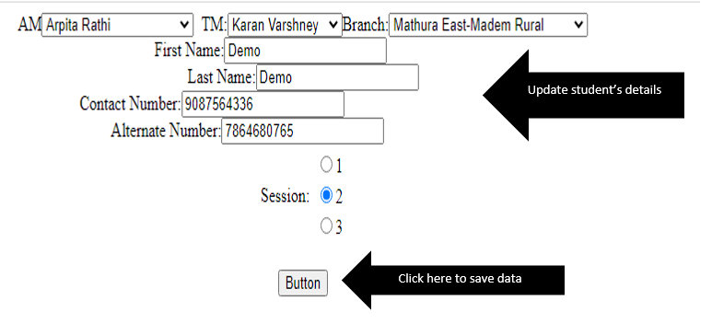

Step4-

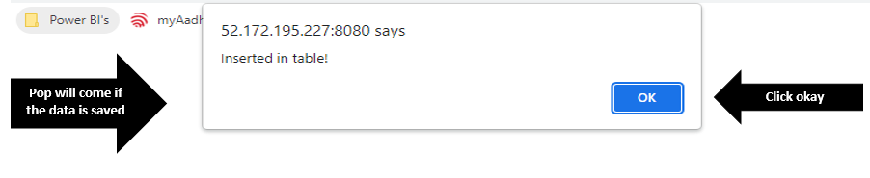

**Link to get the updated information to enroll a student for follow up with the student:**

Step1- Go to the link: http://43.252.88.75:8086/Sign_up_datarural.aspx

Step2- follow the process mentioned in arrows

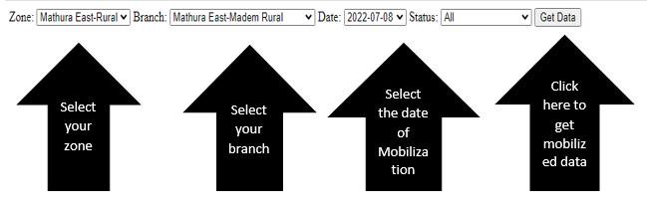

Step3- Click on edit to update mandatory information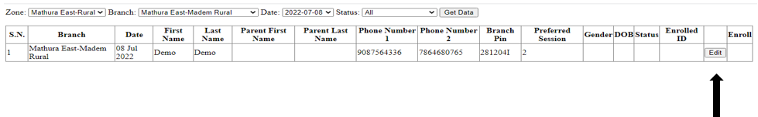

Step4- Fill out the information if student is interested to join classes

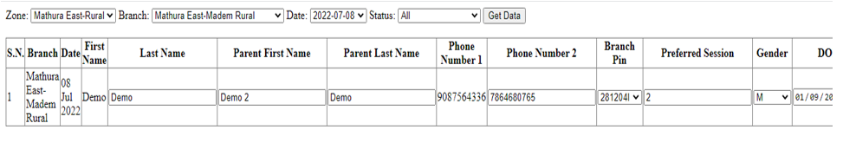

Step5-Update the status

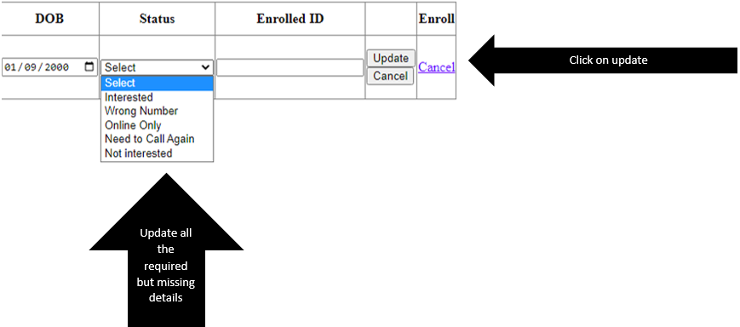

Step6- Go to enroll tab

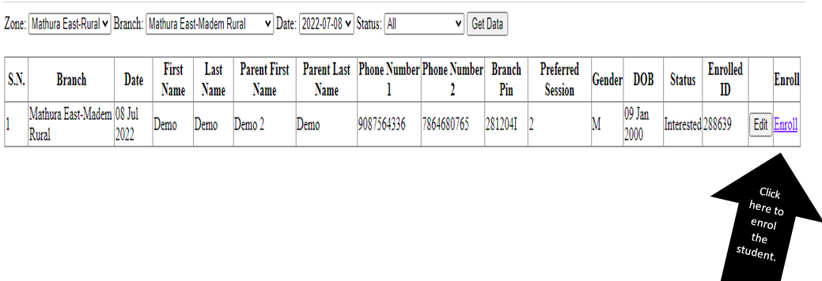

Step7- Login onto LMS to update more information

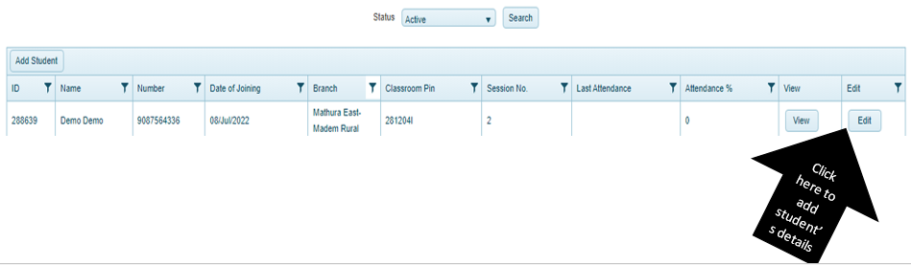

Step8- Fill the required details and save

